**Every Day and Today**

**Put in the gaps the present simple or the present continuous of the verbs. The pictures will help you find the sentence you need.**

1. Ann goes to school every day but today it’s Saturday so she _________________________________.
2. Paul __________________________every Sunday but today he’s playing tennis.
3. They ____________every morning but this morning they______________________because the water is cold.
4. Mrs. Smith ____________________every Saturday morning but this morning she_____________________________.
5. The children _________________________every morning but this morning they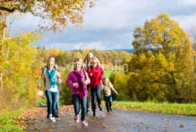__________________.
6. I _________________________every Saturday but this Saturday I_________________________________.

Rania.

**Every Day and Today**

**Put in the gaps the present simple or the present continuous of the verbs. The pictures will help you find the sentence you need.**

1. Ann goes to school every day but today it’s Saturday so she _________________________________.
2. Paul __________________________every Sunday but today he’s playing tennis.
3. They ____________every morning but this morning they______________________because the water is cold.
4. Mrs. Smith ____________________every Saturday morning but this morning she_____________________________.
5. The children _________________________every morning but this morning they__________________.
6. I _________________________every Saturday but this Saturday I_________________________________.

Rania